Instructions for Parent/Teacher Bookings

SECTION 1: Logging into SOBS - School Online Booking System

Visit the school website www.thangoolss.eq.edu.au and click on the Quick Link for ‘Parent teacher interviews’ or the link posted on our Facebook page @ThangoolStateSchool or by clinking on the link that was emailed with this information instructions.

- Click this link – it should take you to a screen that looks like the following (the school name should be the name of the school you are booking at):

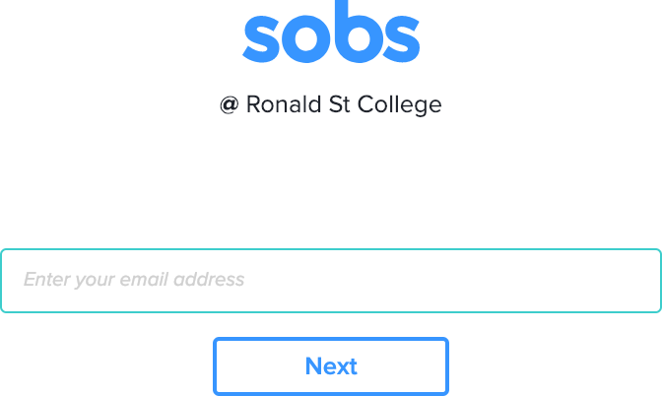

- Enter your email address into the box provided and click “Next”

The email address will be checked for validity. If it is invalid you may see an error like this:

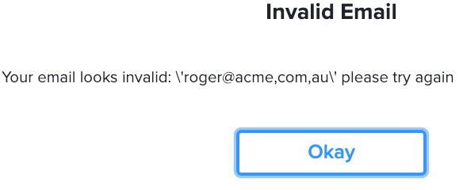

Click “Okay” and re-enter the corrected email address

If you do not have an email address, then you can also enter your mobile phone number in place of the email address.

If you do not have an email address or a mobile phone number, then enter your first and last name in place of the email address. In this instance we may not be able to email you a list of the interviews you book, however you will still be able to record them in your own diary or print them out.

- If this is your first time you may see this screen, it allows you to select the level of security you would like to use on this site:
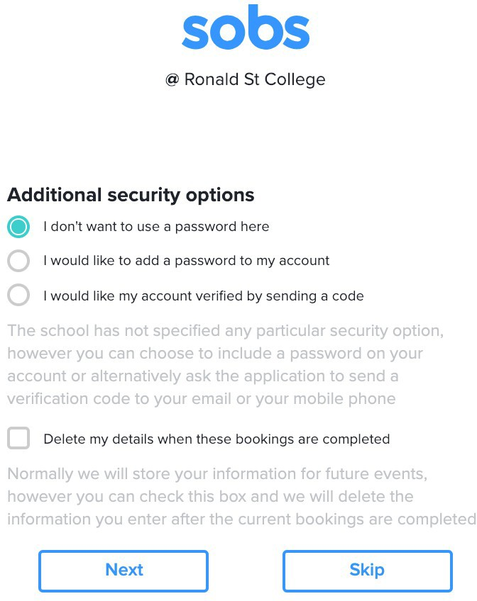
NOTE: The option you choose can not be changed! Once selected the option will stay with this account forever. If you are unsure go with the first option, it is the simplest.

Option 1: “I don't want to use a password here” - if you are not bothered about using a password you can use this option.

Option 2: “I would like to add a password to my account” - you will be prompted to enter a password, this same password will be required to be entered each time you access the site. When selected you can not enter a blank password – you must enter at least one character.

Option 3: “I would like my account verified by sending a code” - this is only available if you have entered a valid email or mobile phone number. We will send a 4 digit code to your email address, or to your mobile phone, we will then require you to enter this code on the next screen.

Optional 4: “Delete my details when these bookings are completed” - after the interview round is complete your details will be deleted from the system. If there are future booking rounds you will be able to register using this process again.

- You chose to add a password to your account:

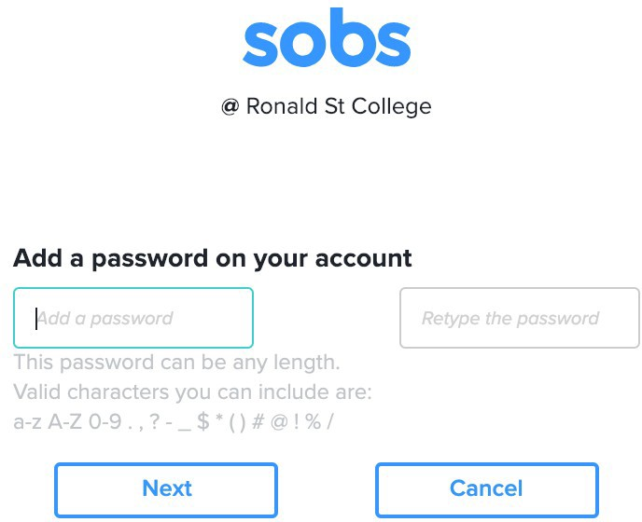
Enter your password twice and click “Next”

- You chose to enter a verification code:
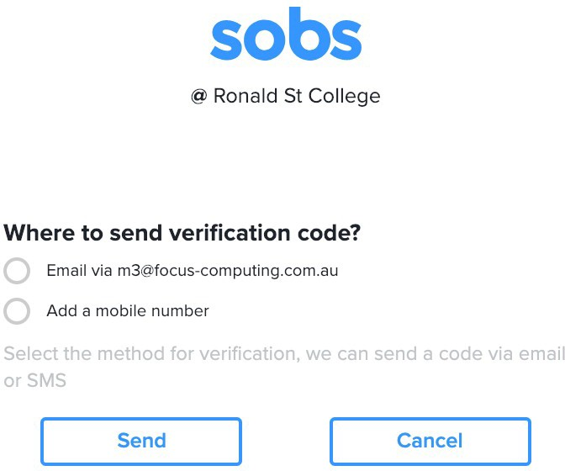
We can send the verification code to your email address or alternatively to a mobile phone number if you would prefer. Select either option and click “Send”.

- The verification code would be sent to the selected account (in this case I have selected my email address):
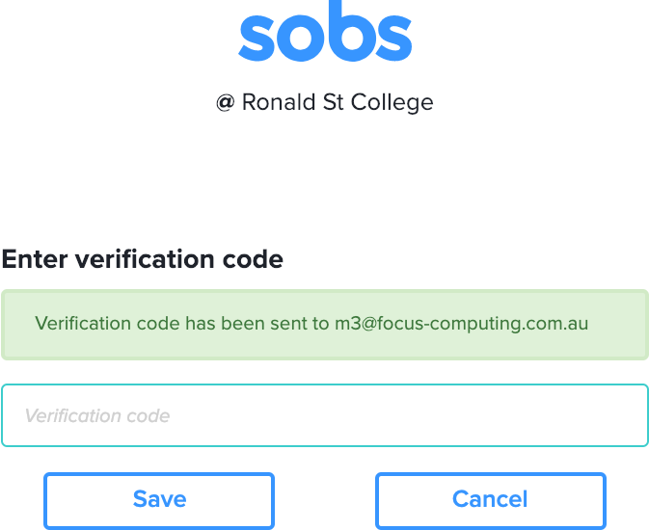
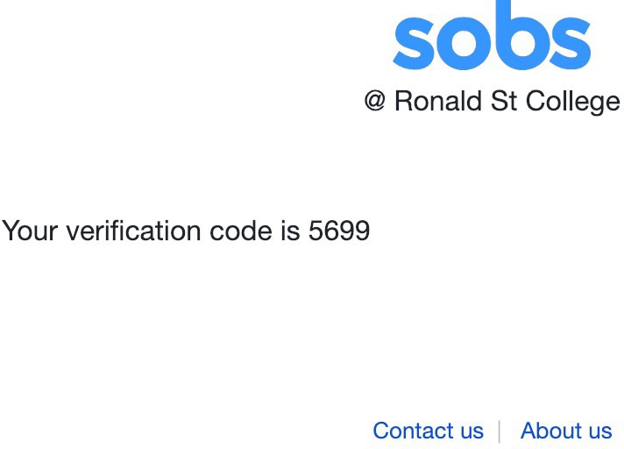

The email is sent immediately – it should arrive within one minute. Be sure to check your spam/junk folder for the email:
Enter the verification code into the box on the form and click “Save”.

- We have now completed the authentication. The application will prompt us for any further information the school would like. Generally this is limited to your name and mobile phone number although there can be others. In this instance because I used the verification code to authenticate the application will allow me to modify my email address:
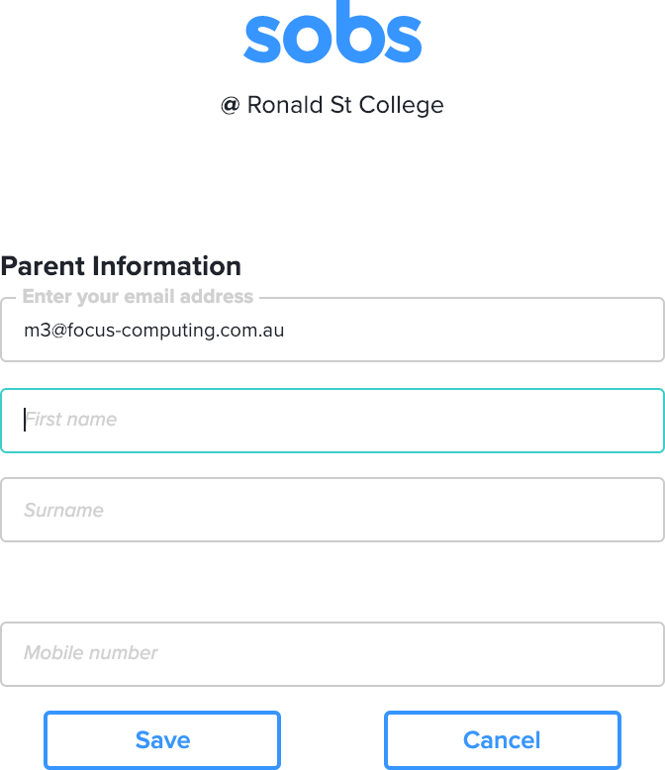

Enter your first and last name, and optionally your mobile phone number, then click “Save”.

SECTION 2: Adding and Updating Student Details

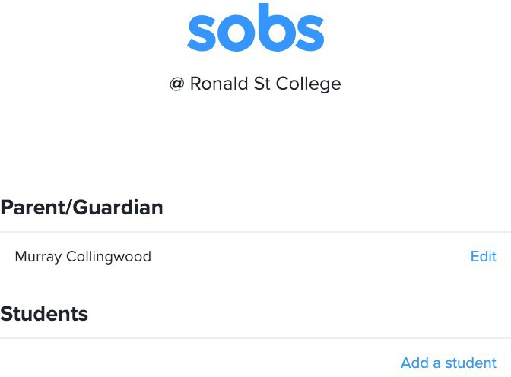

  - Clicking the “Add a student” link will display the following screen:

Enter your child's first and last name. Select the year level from the list available. (These should be year levels that are taught at your child's school).

If you are booking for an enrolment interview you will select the year level and an estimated start date for your child in that year level.

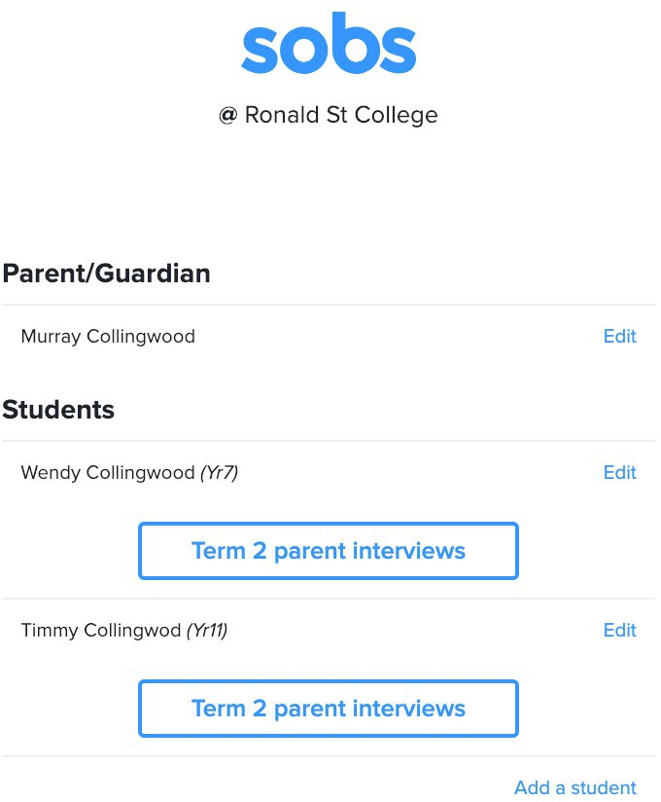
  - Continue adding student entries until you have run out of children:

  - If there are any current bookable events these will be listed under each student. If you can not see a specific event listed be sure to check that your child has the correct year level selected, sometimes an event like Subject Counselling is only valid for a Yr10 student.

  - You can use the “Edit” option to correct the details pertaining to your child. Changing their name and their year level.

If there are no current bookings you will also have the option to delete this entry. Deleted entries will be visible for the remainder of the day and will be removed overnight.

SECTION 3: Booking an Interview

    - In this instance we are going to click on the “Term 2 parent interviews” button.
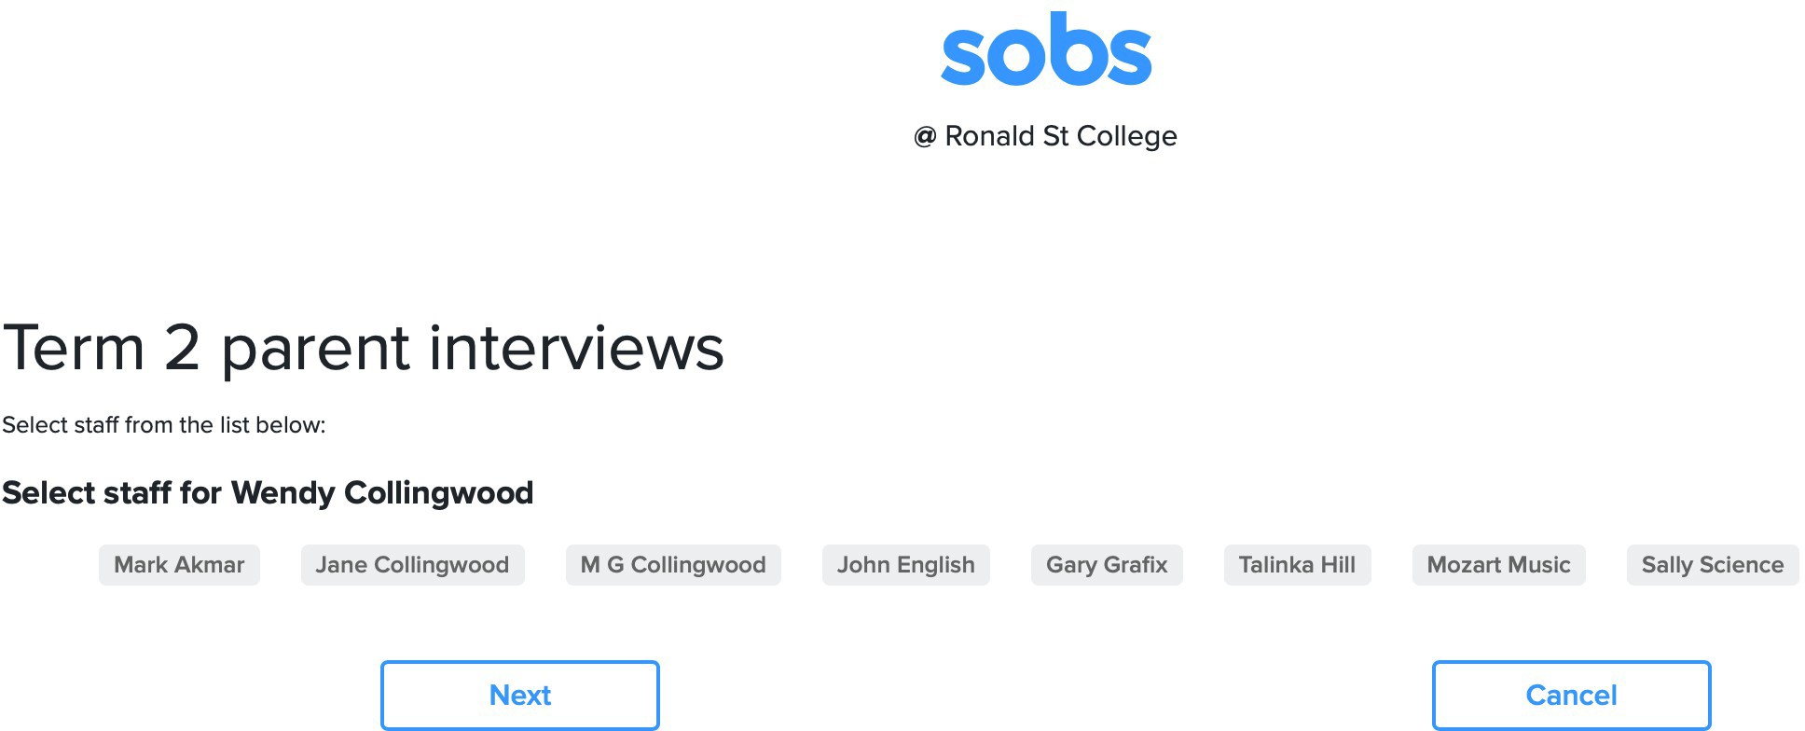
Since Wendy is in year 7 the staff listed are those that teach year 7. Select from the list the teachers you would like to interview with. In this instance I'm choosing three teachers.
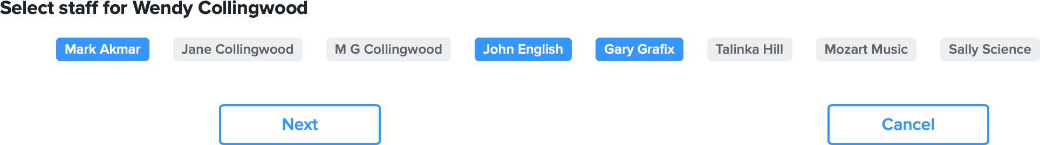
Click “Next”

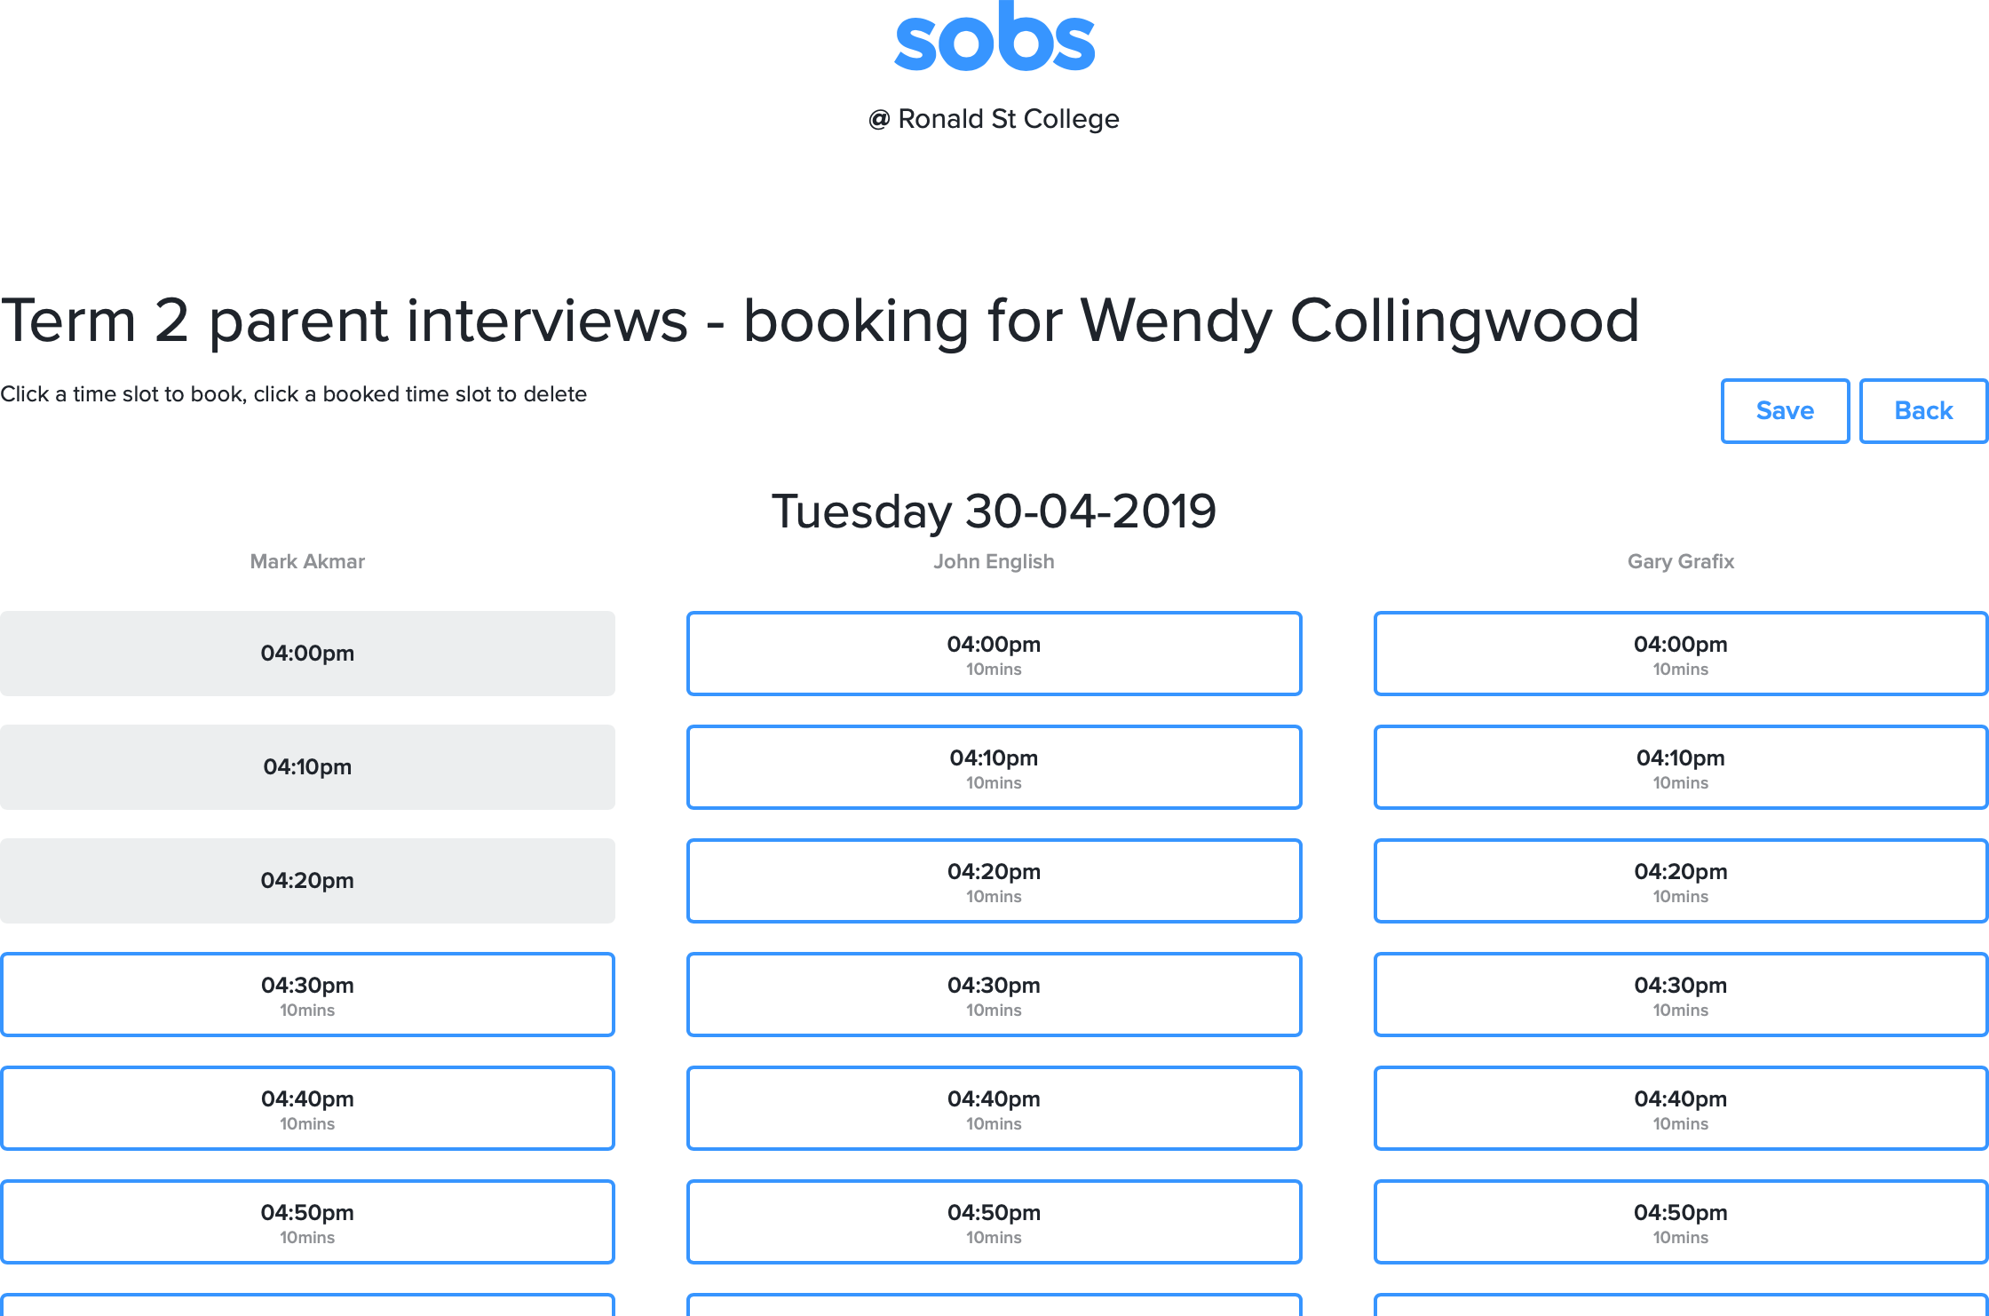
    - We are now presented with a list of the bookable slots for these three teachers. I'm one of the first parents to book so there is plenty of availability.
You can see that Mark Akmar is either unavailable or has already been booked for the first three time slots – you will not be able to book on those slots. You can only book a teacher once, and you can not double book yourself at the same time. To demonstrate this I'm going to book John English for 4:40pm
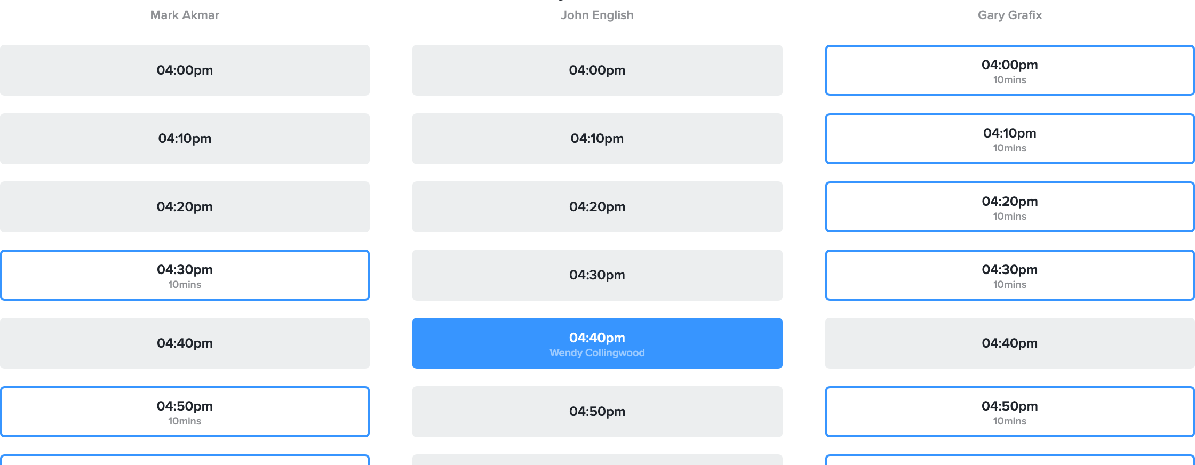

Notice that the other time slots at 4:40pm are now unavailable for booking. Similarly all of the other time slots for John English are unavailable.

Ideally I'm wanting to go straight from one interview to the next, so I'm going to book Mark Akmar for 4:30pm and Gary Grafix for 4:50pm
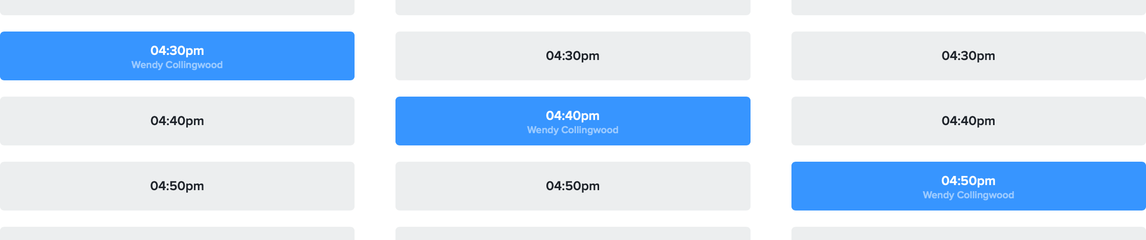

    - You can delete a booking simply by clicking on the blue time slot. This will delete the booking and restore the other bookable options.

    - Click “Save” to return to the list of students

    - We now have a list of three bookings for Wendy. An Email and Print button have also appeared. We haven't finished booking yet so we will wait to Email / Print until the rest of our bookings are completed. Clicking on the “Term 2 parent interviews” button for Timmy.
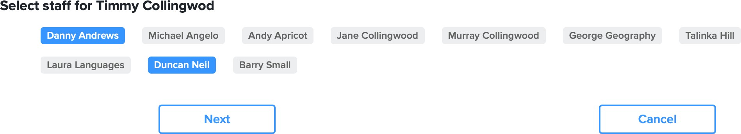

For Timmy we are going to interview with Danny Andrews and Duncan Neil – click “Next”

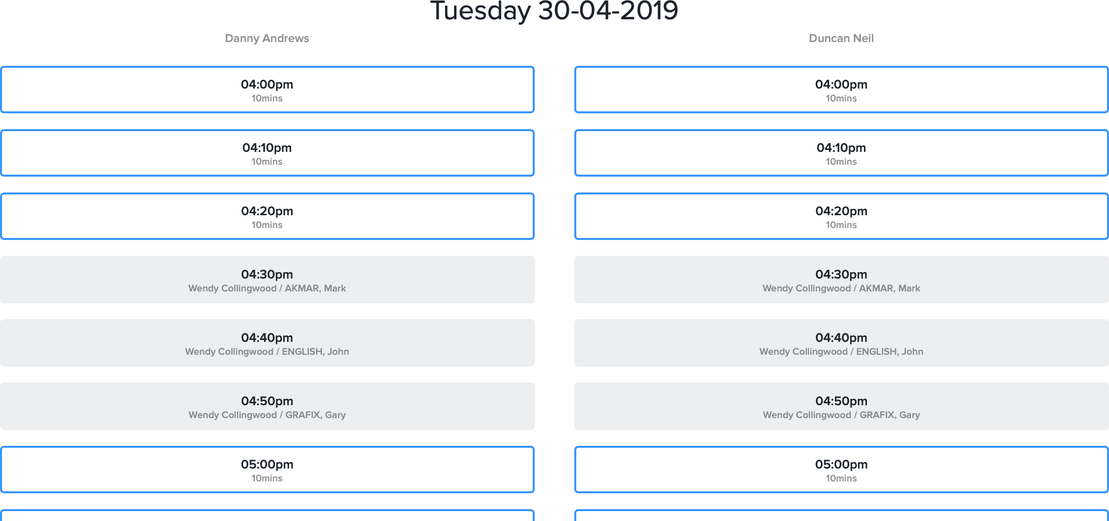
    - The available time slots show some more unavailable time slots, however this time they relate to the times we have already booked for Wendy's interviews.
My most efficient books are once again immediately before of after the current bookings I have, so I will book Danny at 4:10pm and Duncan at 4:20pm
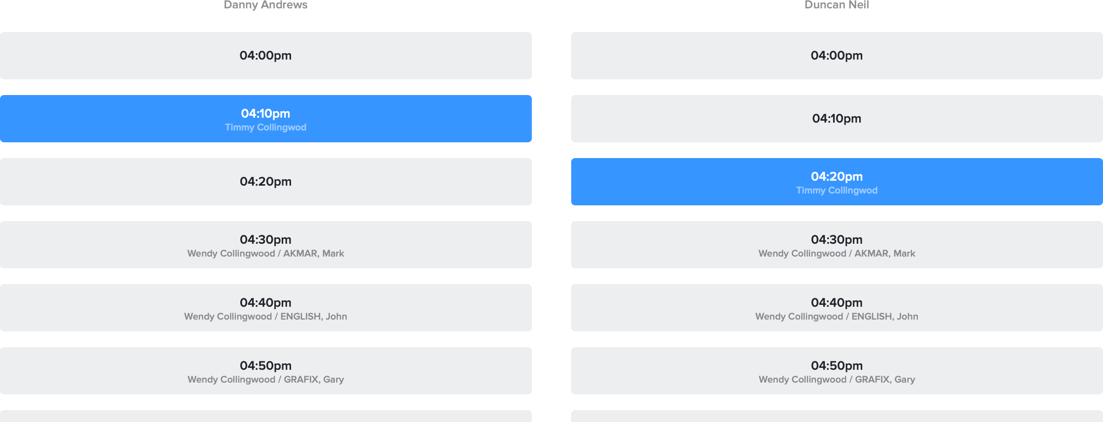

Once again I will click “Save” to return to the list of students.

    - I now have all my bookings completed.
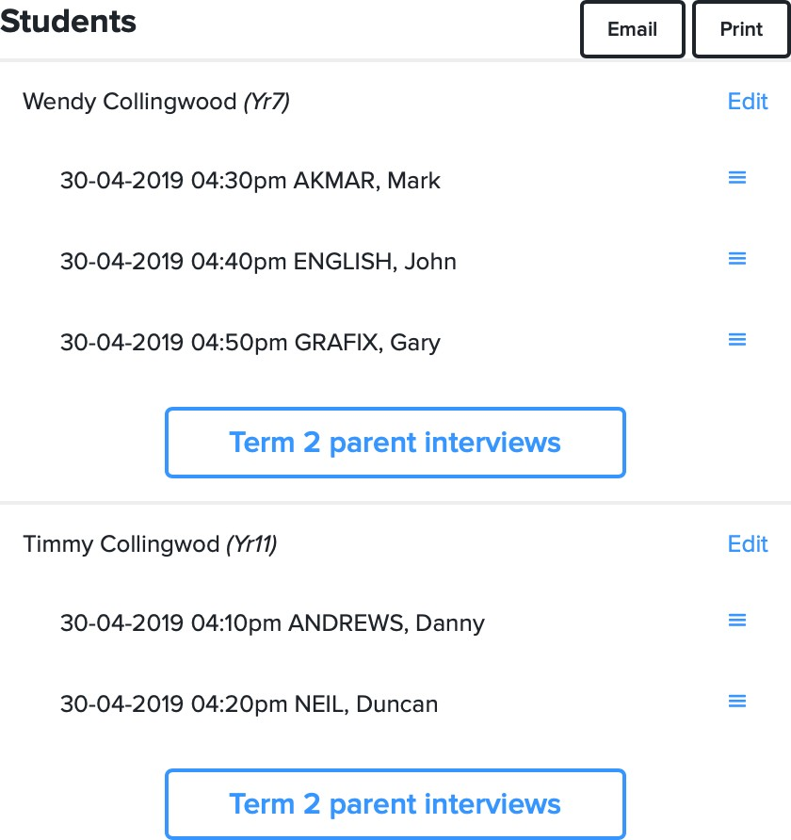

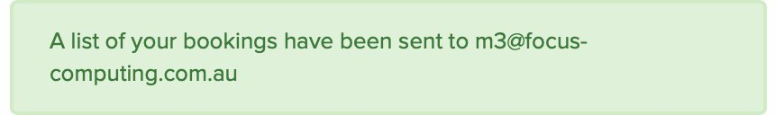
    - Clicking the “Email” button will send a list of the bookings to my email.

    - Clicking the “Print” button will display a list of the bookings, with time, teacher name and the room where the interview will be held in brackets after the teacher name, that I can then print (on most web browsers this is Control + P).
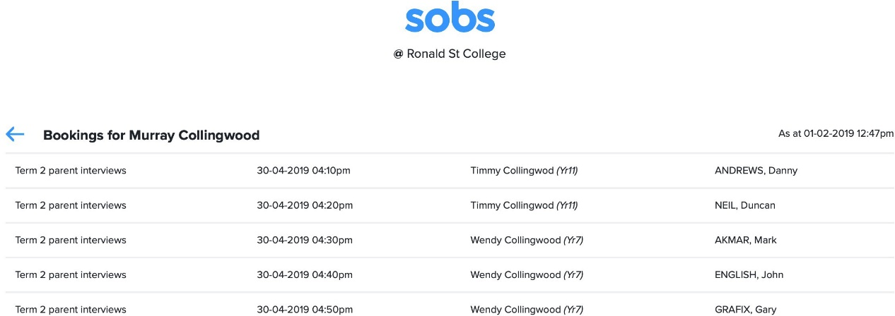
(G14)

(G12)

(G11)

(H01)

(N01)

    - There is no specific logoff option – you can just close your browser window.

